Python Practice

248518 Gaurav B Raskar

Q.32.

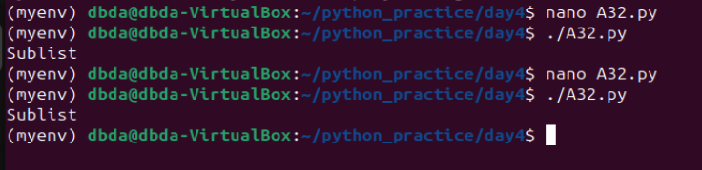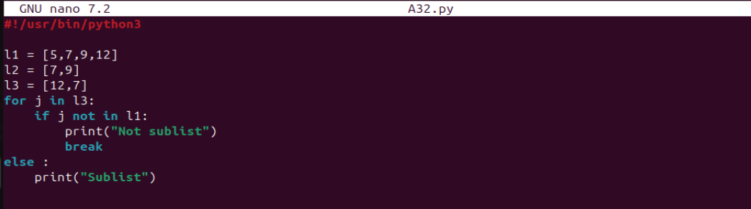

Q.